Project Topic on

Vehicle Detection and Tracking

Leader & Main Team Member:

*Houssam El Mir*

*Team Leader Signature:*

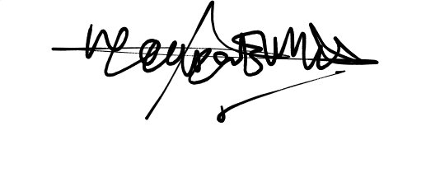

Learn about real-time object detection, tracking, and integration with video streams.

**Objective:**

The objective of this project is to develop a real-time system for detecting and tracking vehicles in video streams. The system will identify and label different types of vehicles, such as cars, buses, and trucks, and track their movements across frames in a video. This project focuses on integrating object detection models with tracking algorithms to analyze video data effectively.

**Tools and Technologies:**

- Programming Language: Python

- Libraries: OpenCV, NumPy, SORT (Simple Online and Realtime Tracking), YOLO (You Only Look Once)

- Dataset: Pre-recorded video footage or live video streams (e.g., from a camera or video file)

**Steps Involved:**

1. Load and Preprocess the Video Stream:

- Capture video frames from a video file or a live camera feed.

- Preprocess each frame to ensure it's suitable for detection and tracking.

2. Vehicle Detection Using YOLO:

- Utilize the YOLO object detection model to identify vehicles in each frame.

- YOLO provides bounding boxes around detected vehicles, along with confidence scores and class labels (e.g., car, truck, bus).

3. Vehicle Tracking Using SORT:

- Integrate the SORT algorithm to track detected vehicles across consecutive frames.

- Assign unique IDs to each vehicle, allowing the system to follow individual vehicles as they move through the video.

4. Display and Analyze Results:

- Display the video frames with overlaid bounding boxes and IDs for each tracked vehicle.

- Output video results to visualize how vehicles are detected and tracked in real-time.

**Learning Outcomes:**

- Object Detection: Understand how object detection models like YOLO work and how they can be applied to identify vehicles in images or video frames.

-Real-Time Processing: Gain experience in processing video streams in real-time, ensuring that the system can handle the speed and volume of incoming video data.

-Object Tracking: Learn how to integrate object tracking algorithms (e.g., SORT) to maintain persistent identification of objects across multiple frames.

-Video Stream Integration: Develop skills in integrating object detection and tracking within video streams, and explore how to output the results effectively.

**Challenges and Considerations:**

- Real-Time Performance: Ensuring the system operates efficiently in real-time, especially when processing high-resolution video streams or working with limited computational resources.

- Accuracy of Detection and Tracking: Balancing the accuracy of vehicle detection with the speed of processing, and minimizing issues like false positives or missed detections.

- Handling Occlusions: Managing cases where vehicles overlap or move out of the frame, which can complicate tracking.

This project provides a practical introduction to computer vision techniques, especially in the context of real-time applications, and is a stepping stone toward more advanced topics like multi-object tracking and autonomous driving systems.

*Github Project Source:  
 https://github.com/houssamelmir/Vehicle-Detection-Tracking.git*